Restore Investwell database
For SQL 2005

Please follow the following steps to Restore database in SQL 2005 Manually
Step 1: Open SQL server Management Studio
Step 2: Connect sql server

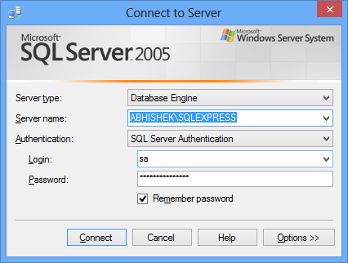

Step 4: After opening the Investwell right click on Database click on Restore Database .

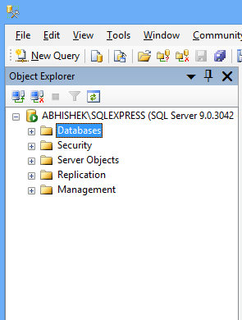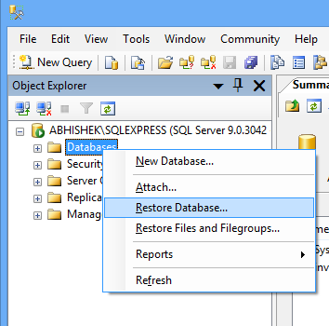

Step 5: After clicking on Restore Database a new window will open for restoring the database.
Here we have to fill few details:

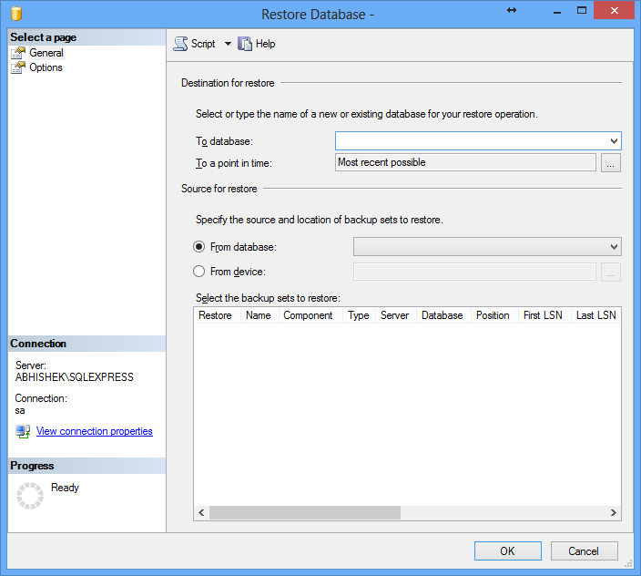

- In To Database Fill Investments
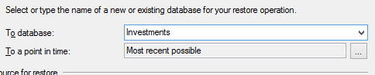

- After that go to From Device and select it.

- After Clicking on brows button a new tab will open here you have to click on Add button to select the backup file to restore
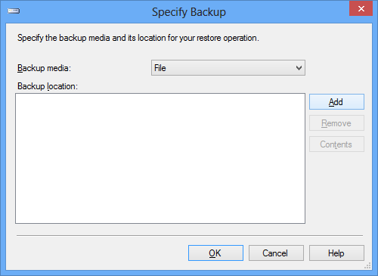

- After that Locate Backup file tab will open here you need to select the backup file.
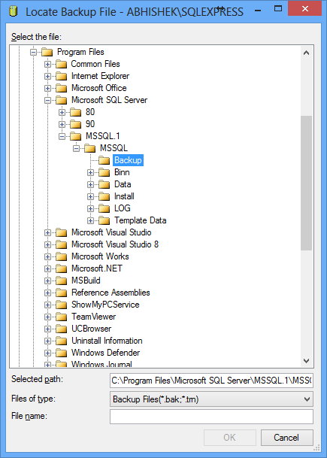

- Goto backup location and select the file then click on OK button.
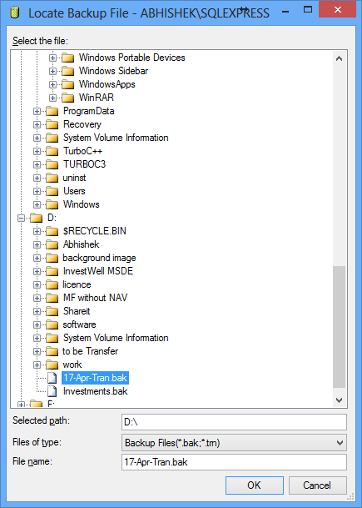

- After selection of backup file click on OK button
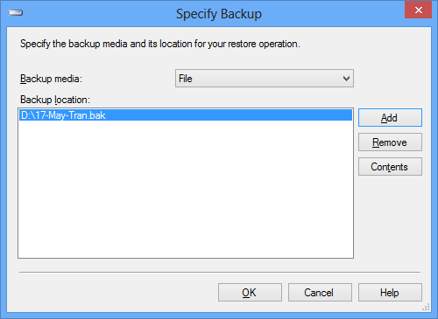

- When file is selected then click on Restore check button and then move to Option page
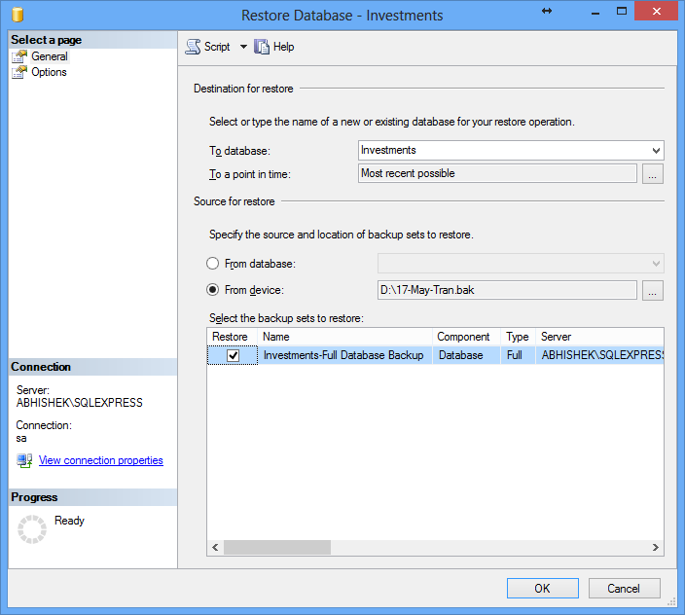

- In Option page click on check box of Overwrite the exiting database and Prompt before restore each backup then click on Ok button your restoreing process will start automatilly.
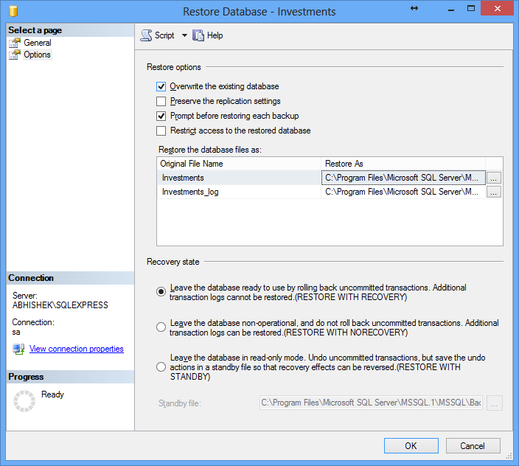

Do the same process for the Nav data also only we need to do change in to database
For Tran.bak file we will write Investments in To database
For Nav.bak file we will write Investwelldata in To database
And rest of the process will be same
Transation in Investments
Nav in Investwelldata

