Go to Mailback Report
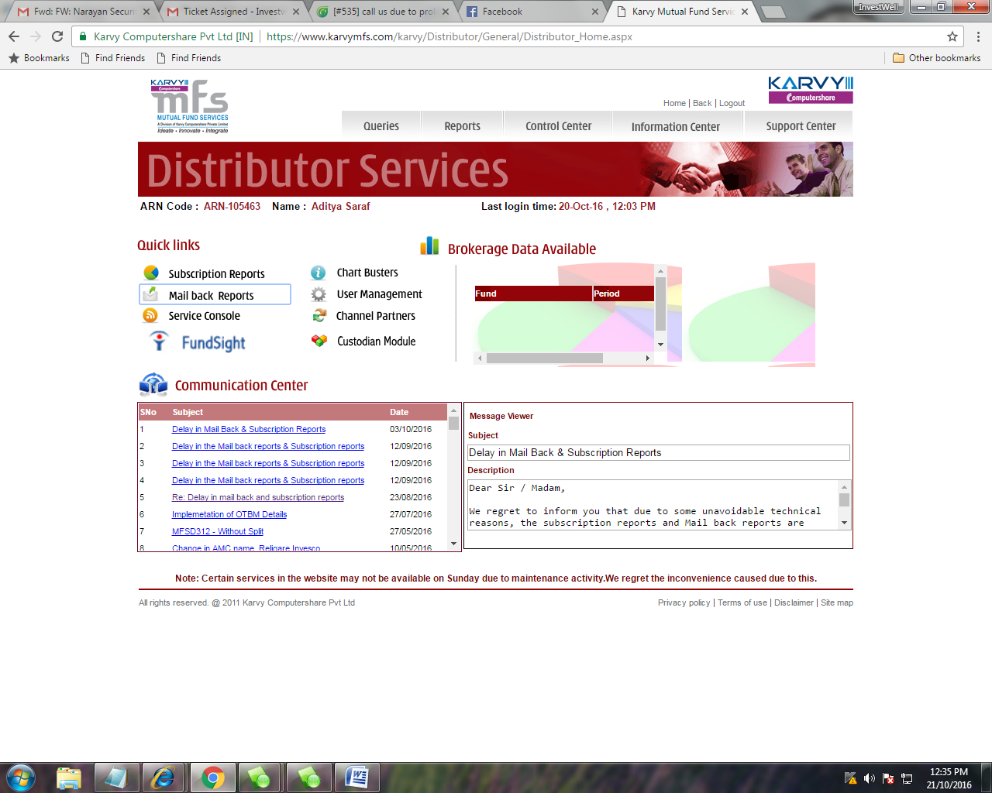

Then MFSD 201-Transaction Report

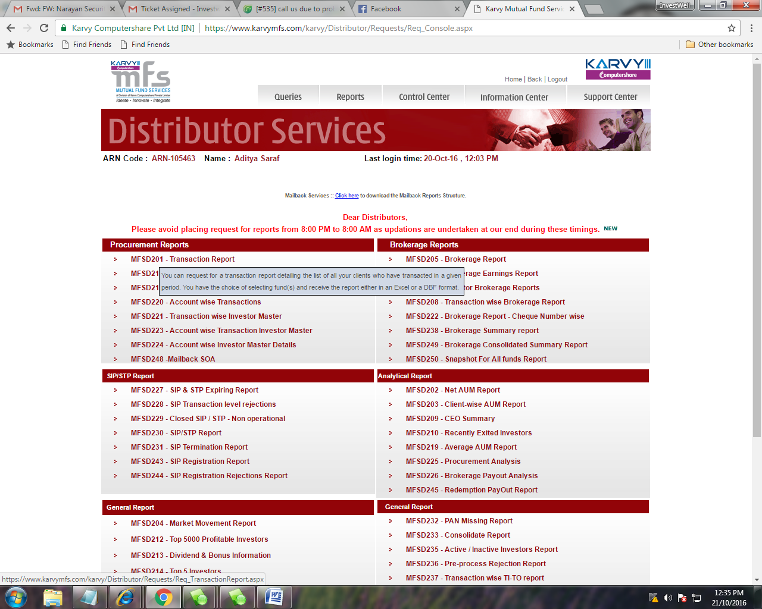
Then MFSD 201-Transaction Report
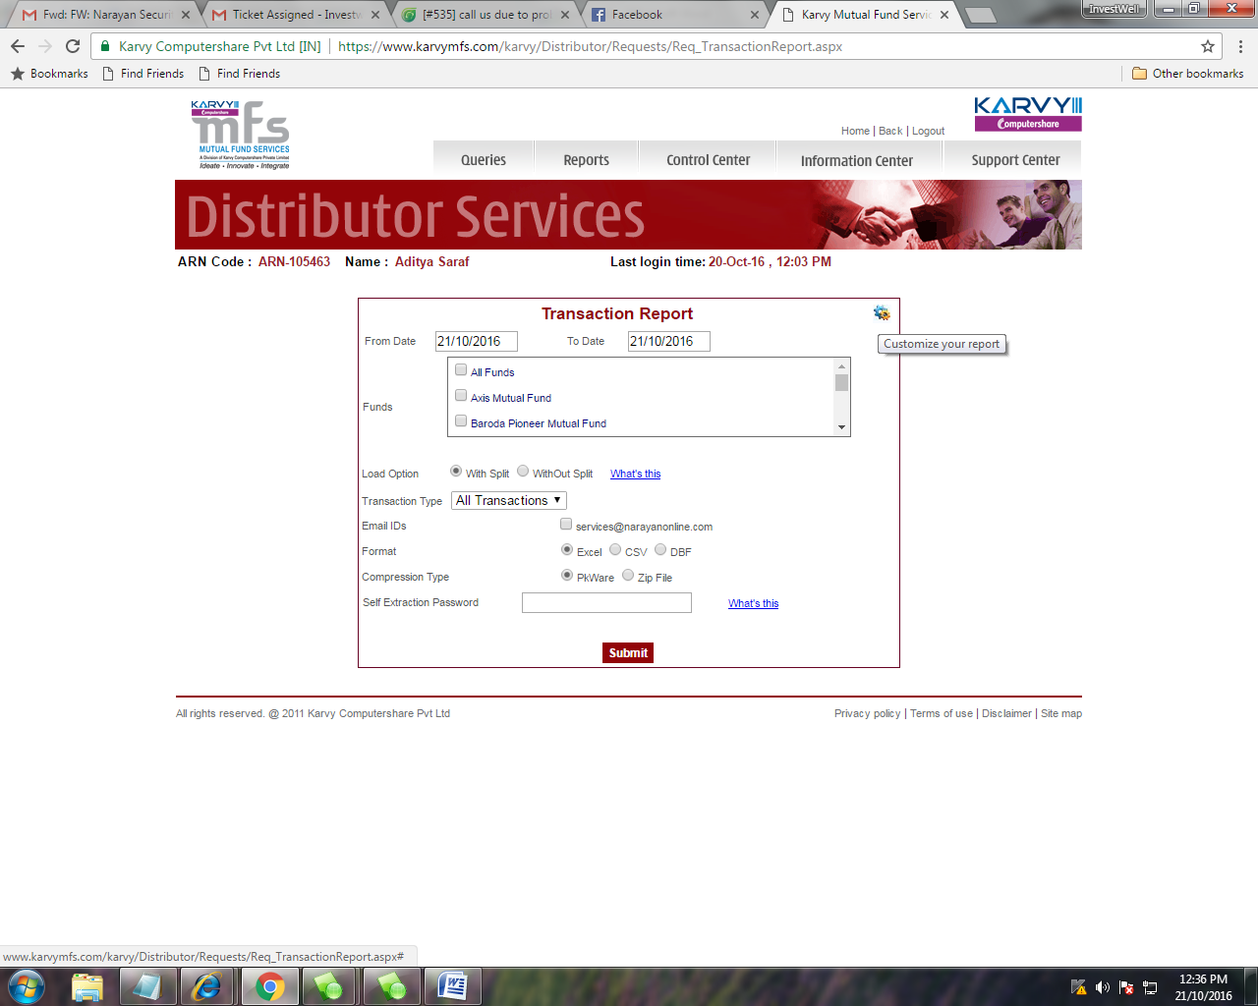
Select Customize your report Option (Gear Image)

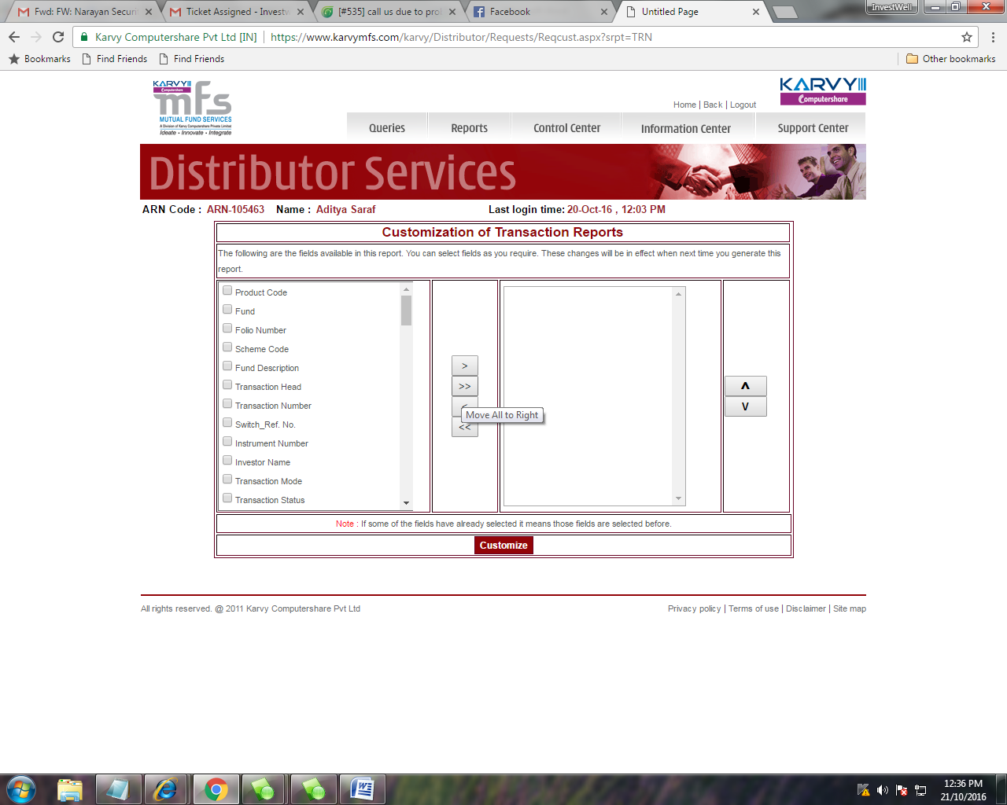
Then Click on Move All to Right (Arrow Key)
And click on Customize Option which show below..

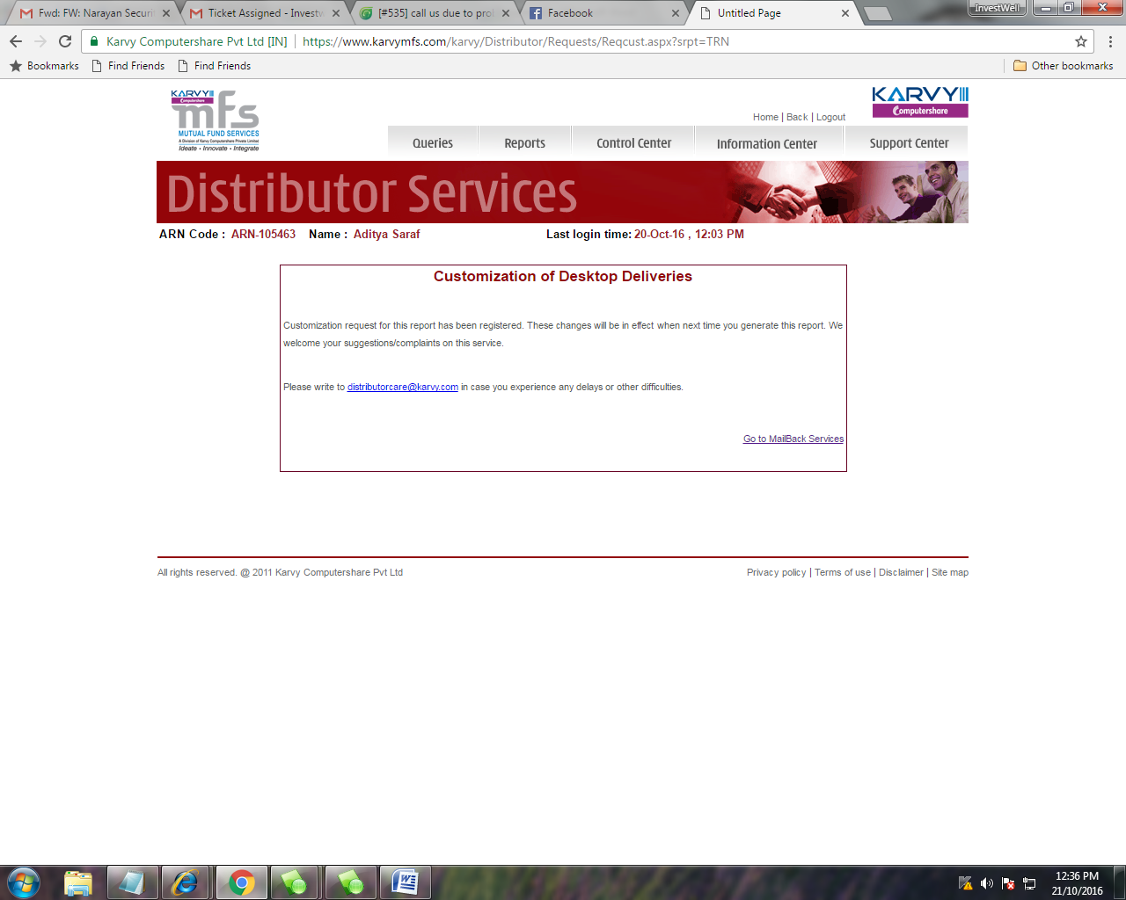

Then Pls Again Call a Transaction File..
This Function has to be done one Time only.. Then karvy send all reports as Customize Reports..

